**Writing Task 2: Cohesion**

***1. Which of these looks like a good writing task 2 essay? (Each block represents a paragraph).***

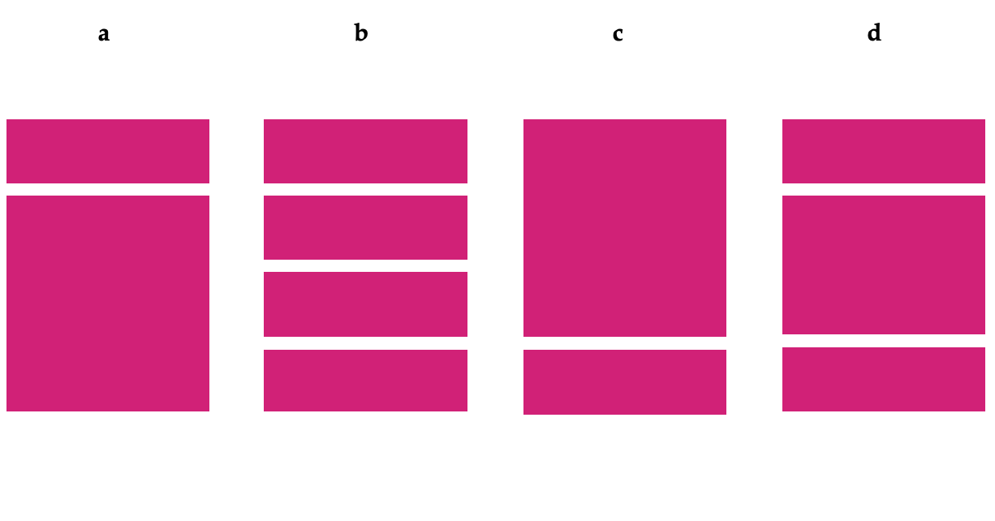

**b is correct. The first paragraph should include background information, which normally rephrases the question, and a thesis statement which states what you are going to write about. The second and third paragraphs represent your main arguments (and counter arguments) and the final paragraph is the conclusion, which should match your thesis statement.**

Thesis statement

Background information

Argument against

Argument against

Conclusion: Against

Background information

Argument for and against

Argument for and against

Conclusion: For

Background information

Thesis statement

Argument for

Argument against + counter argument for

Conclusion: For

Thesis statement

Argument for

Argument against

Argument for

Conclusion: For

***2. Which of these structures is ideal for writing task 2? What’s wrong with the others?***

**a b c d**

**c is correct for the reasons mentioned in the previous exercise. Even if you fully support one side of the argument, it will still look good if you can take an argument from the other side and give an argument against it.**

***3. True or false?***

1. When asked to give your opinion, your position should be clear in the first paragraph.

True. This is what goes into a thesis statement.

1. You should use informal idioms in your writing.

False. Writing task 2 is not an informal essay. You don’t have to be overly formal, but don’t be informal.

1. You can change your opinion during the essay.

False. This is why writing a thesis statement and following it is important.

1. You will lose marks if you write over the word limit.

False. Even though it is not recommended to write over the word limit, as you will not gain any marks, you should never write under the word limit.

1. Plan your structure before you start writing.

True. You should especially plan your overall opinion in the thesis statement (if required) and the main arguments you will present in your body paragraphs.

1. You can use headings and bullet points to support your essay.

False. Headings are used in long academic essays. An IELTS essay is too short for either of these techniques. Your work must flow in full paragraphs.