**Writing Task 2: Cohesion**

***1. Which of these looks like a good writing task 2 essay? (Each block represents a paragraph).***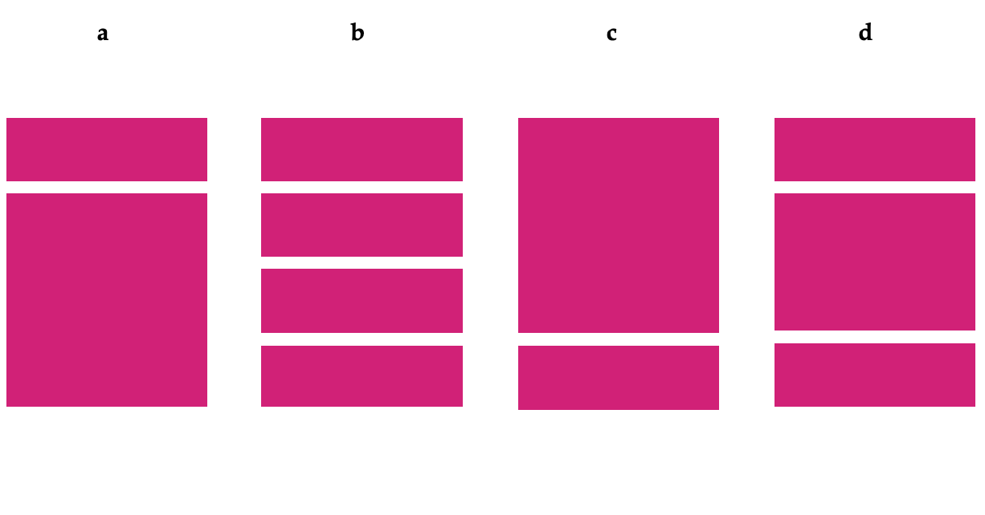

***2. Which of these structures is ideal for writing task 2? What’s wrong with the others?***

Thesis statement

Background information

Argument against

Argument against

Conclusion: Against

Background information

Argument for and against

Argument for and against

Conclusion: For

Background information

Thesis statement

Argument for

Argument against + counter argument for

Conclusion: For

Thesis statement

Argument for

Argument against

Argument for

Conclusion: For

**a b c d**

***3. True or false?***

1. When asked to give your opinion, your position should be clear in the first paragraph.
2. You should use informal idioms in your writing.
3. You can change your opinion during the essay.
4. You will lose marks if you write over the word limit.
5. Plan your structure before you start writing.
6. You can use headings and bullet points to support your essay.